Lab 4: Perform NFS Enumeration

**Lab Scenario**

As a professional ethical hacker or penetration tester, the next step after LDAP enumeration is to perform NFS enumeration to identify exported directories and extract a list of clients connected to the server, along with their IP addresses and shared data associated with them.

After gathering this information, it is possible to spoof target IP addresses to gain full access to the shared files on the server.

**Lab Objectives**

* Perform NFS enumeration using RPCScan and SuperEnum

**Overview of NFS Enumeration**

NFS (Network File System) is a type of file system that enables computer users to access, view, store, and update files over a remote server. This remote data can be accessed by the client computer in the same way that it is accessed on the local system.

Task 1: Perform NFS Enumeration using RPCScan and SuperEnum

RPCScan communicates with RPC (remote procedure call) services and checks misconfigurations on NFS shares. It lists RPC services, mountpoints,and directories accessible via NFS. It can also recursively list NFS shares. SuperEnum includes a script that performs a basic enumeration of any open port, including the NFS port (2049).

Here, we will use RPCScan and SuperEnum to enumerate NFS services running on the target machine.

Before starting this lab, it is necessary to enable the NFS service on the target machine (**Windows Server 2019**). This will be done in **steps 1-6**.

1. In the **Windows Server 2019** machine, click the **Start** button at the bottom-left corner of **Desktop** and open **Server Manager**.
2. The **Server Manager** main window appears. By default, **Dashboard** will be selected; click **Add roles and features**.

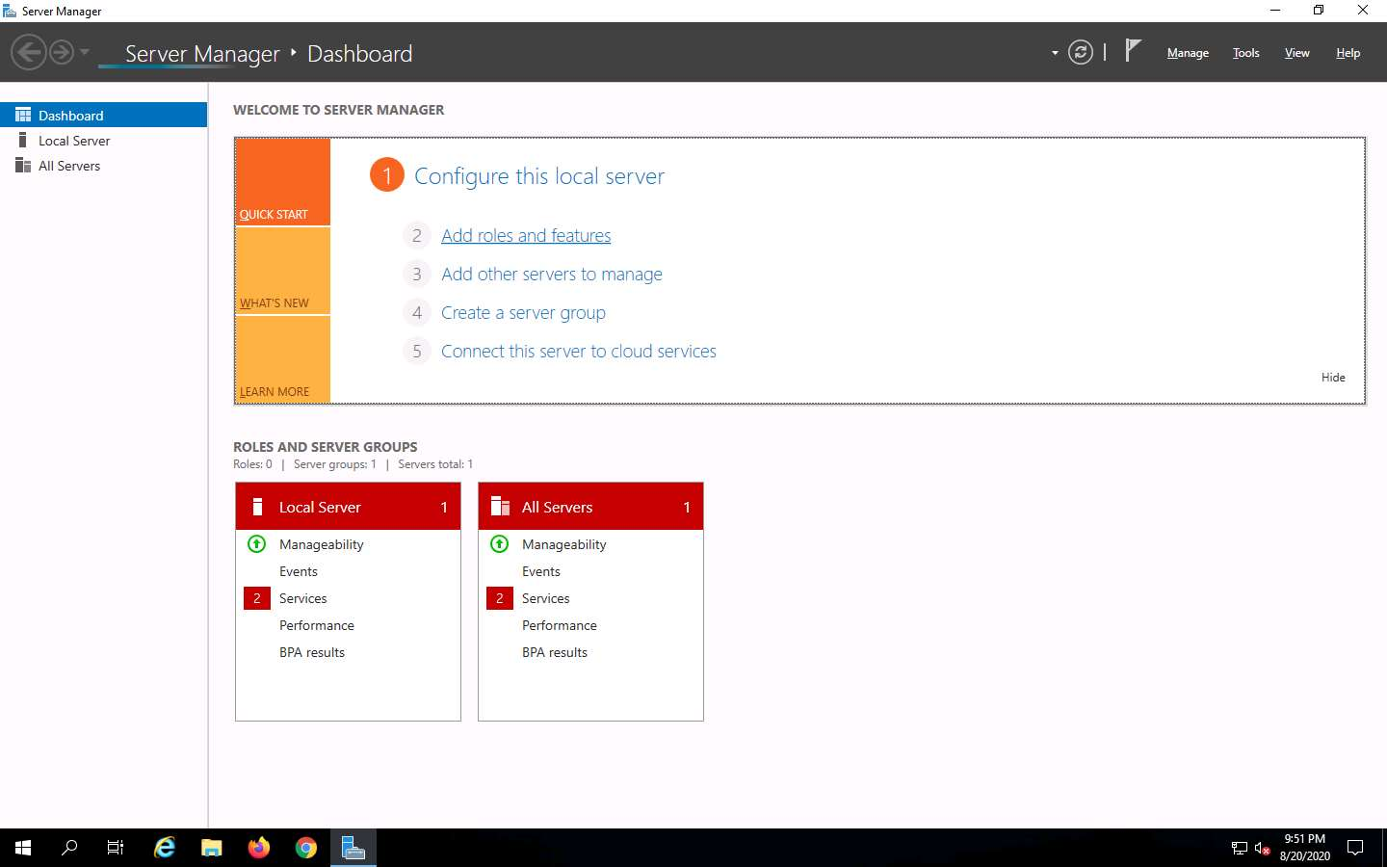

1. The **Add Roles and Features Wizard** window appears. Click **Next** here and in the **Installation Type** and **Server Selection** wizards.
2. The **Server Roles** section appears. Expand **File and Storage Services** and select the checkbox for **Server for NFS** under the **File and iSCSI Services** option, as shown in the screenshot. Click **Next**.

In the **Add features that are required for Server for NFS**? pop-up window, click the **Add Features** button.

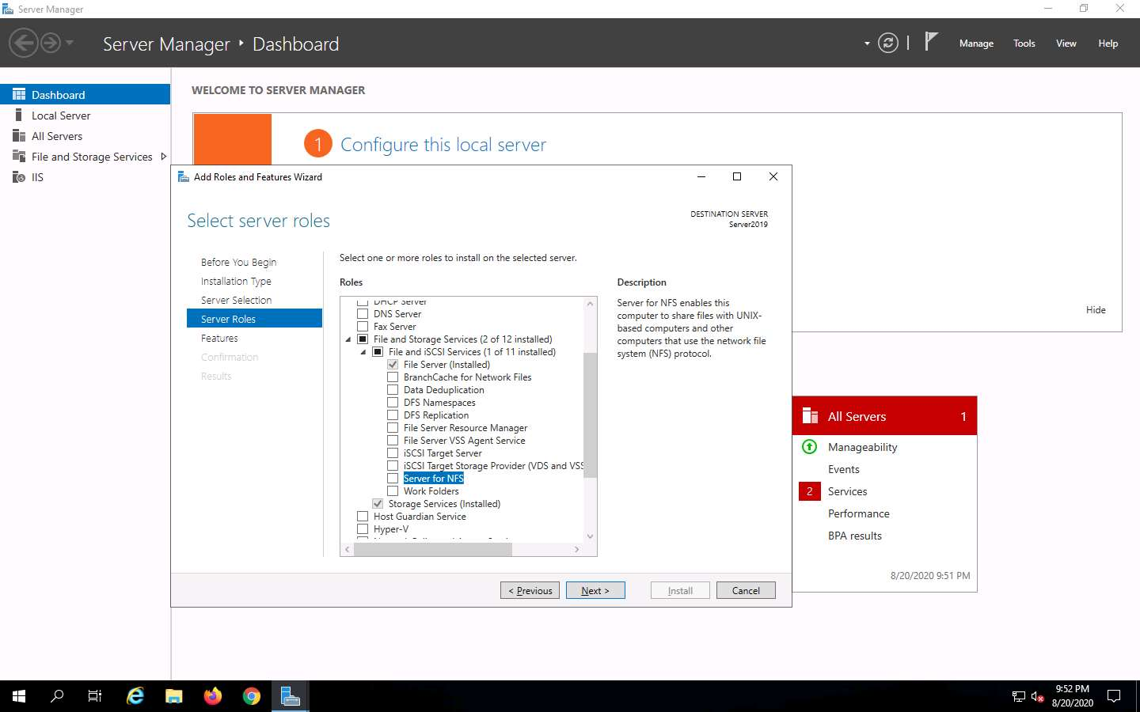

1. In the **Features** section, click **Next**. The **Confirmation** section appears; click **Install** to install the selected features.

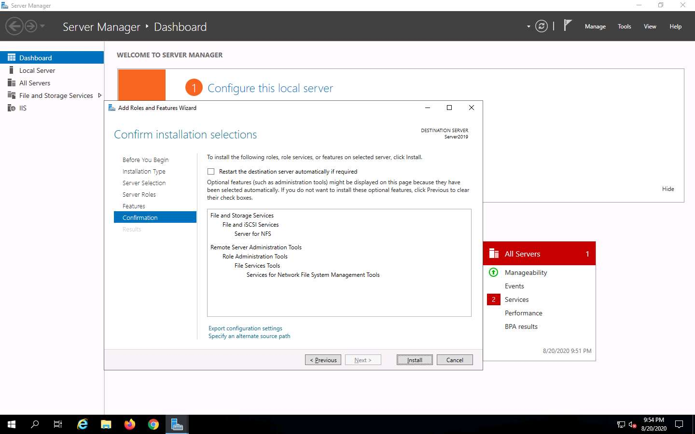

1. The features begin installing, with progress shown by the **Feature installation** status bar. When installation completes, click **Close**.

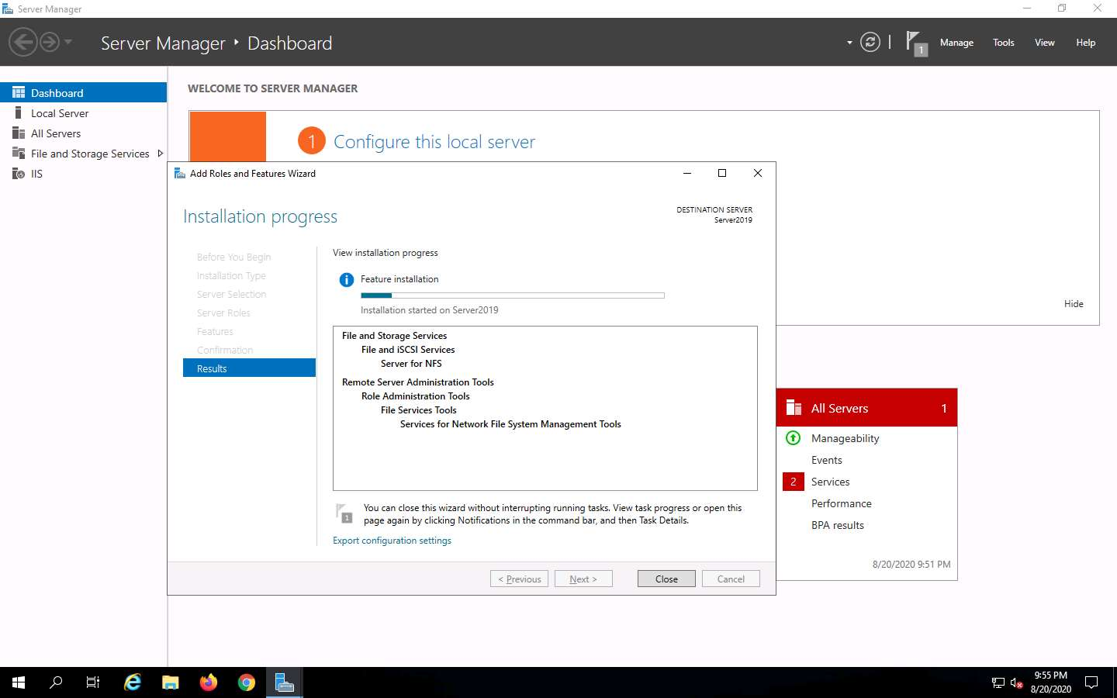

1. Having enabled the NFS service, it is necessary to check if it is running on the target system (**Windows Server 2019**). In order to do this, we will use **Parrot Security** machine.
2. Click [Parrot Security](https://labclient.labondemand.com/Instructions/fbc14e54-d7e0-48c8-a161-917c8a669df5?rc=10) to switch to the **Parrot Security** machine.
3. Click the **MATE Terminal** icon at the top-left corner of the **Desktop** window to open a **Terminal** window.

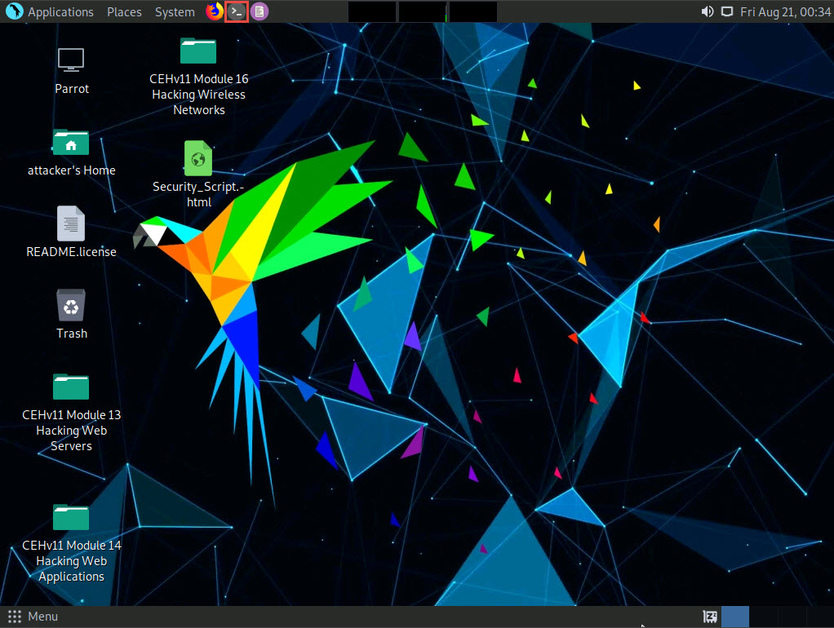

1. A **Parrot Terminal** window appears. In the terminal window, type **sudo su** and press **Enter** to run the programs as a root user.
2. In the **[sudo] password for attacker** field, type **toor** as a password and press **Enter**.

The password that you type will not be visible.

1. Now, type **cd** and press **Enter** to jump to the root directory.

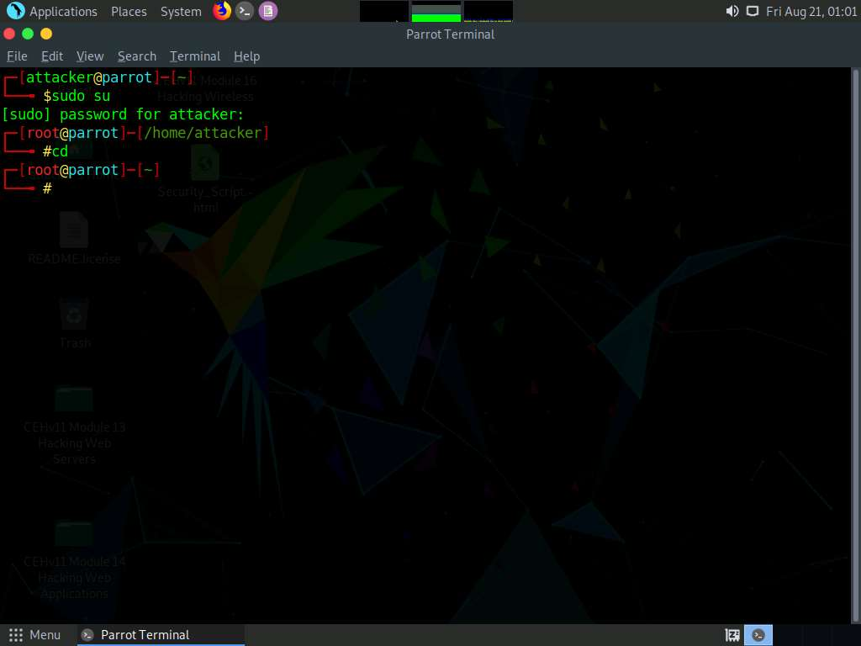

1. In the terminal window, type **nmap -p 2049 [Target IP Address]** (in this case, **10.10.10.19**) and press **Enter**.
2. The scan result appears indicating that port 2049 is opened, and the NFS service is running on it, as shown in the screenshot.

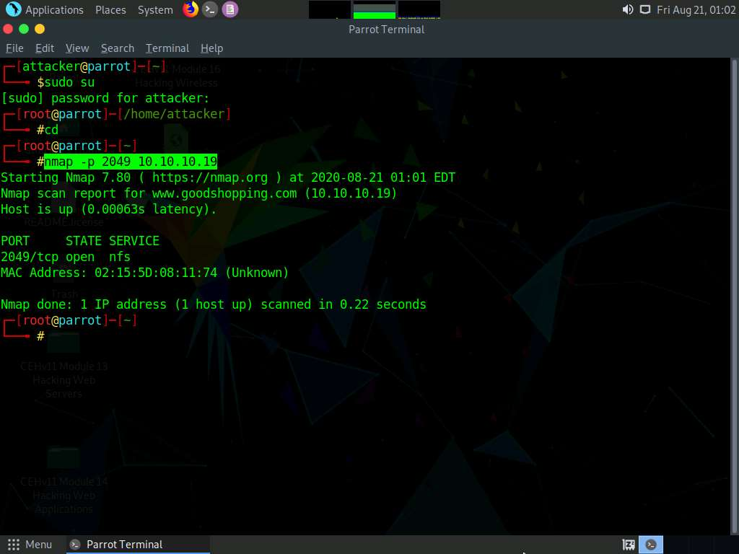

1. Type **cd SuperEnum** and press **Enter** to navigate to the **SuperEnum** folder.
2. Type **echo "10.10.10.19" >> Target.txt** and press **Enter** to create a file having a target machine's IP address (**10.10.10.19**).

You may enter multiple IP addresses in the **Target.txt** file. However, in this task we are targeting only one machine, the **Windows Server 2019 (10.10.10.19)**. The IP address may vary in your lab environment.

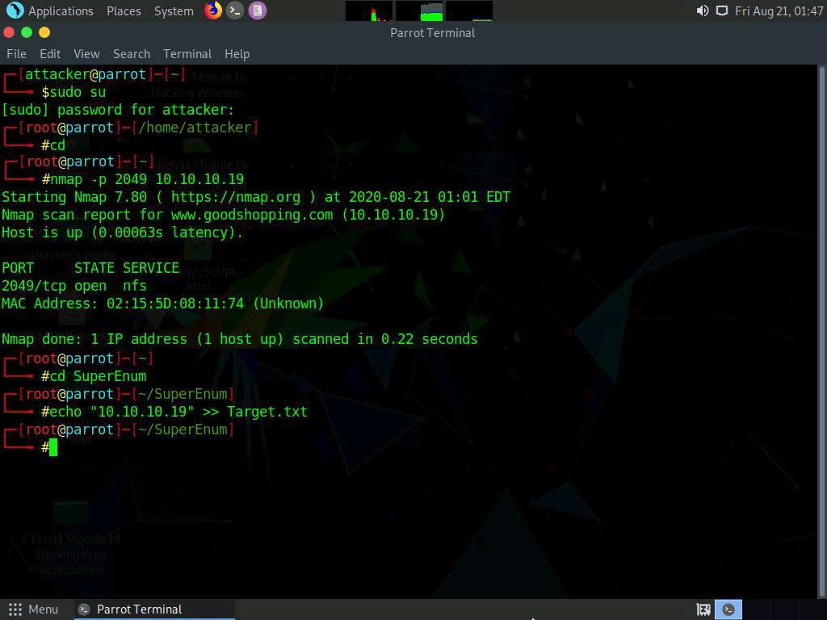

1. Type **./superenum** and press **Enter**. Under **Enter IP List filename with path**, type **Target.txt**, and press **Enter**.

If you get an error running the ./superenum script, type **chmod +x superenum** and press **Enter**, then repeat **Step 17**.

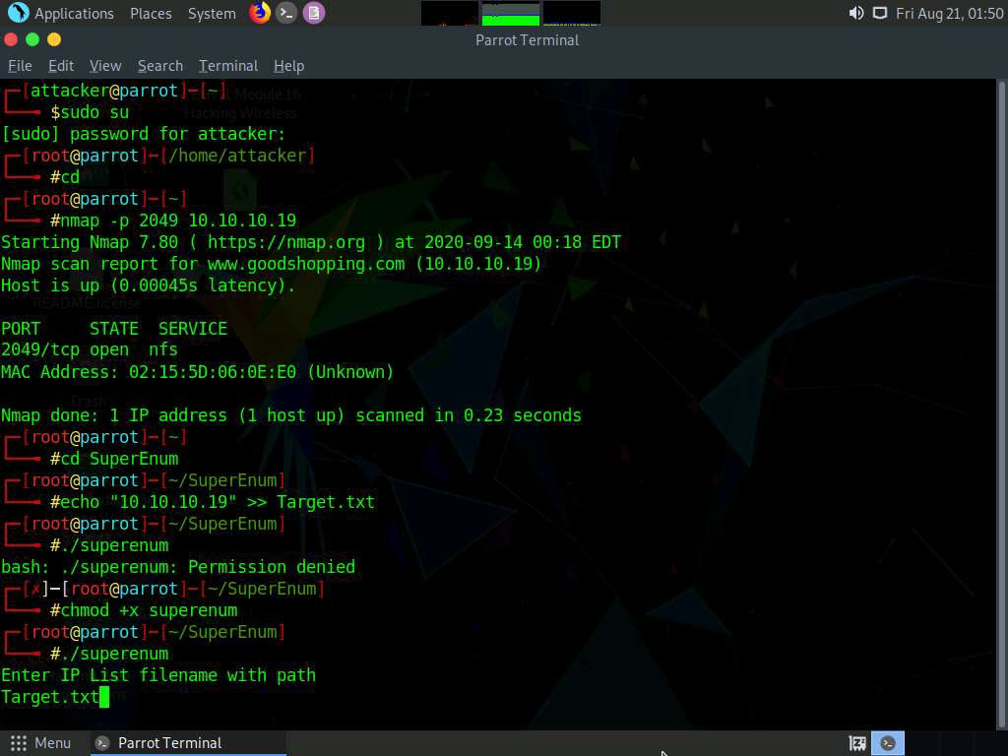

1. The script starts scanning the target IP address for open NFS and other.

The scan will take approximately 15-20 mins to complete.

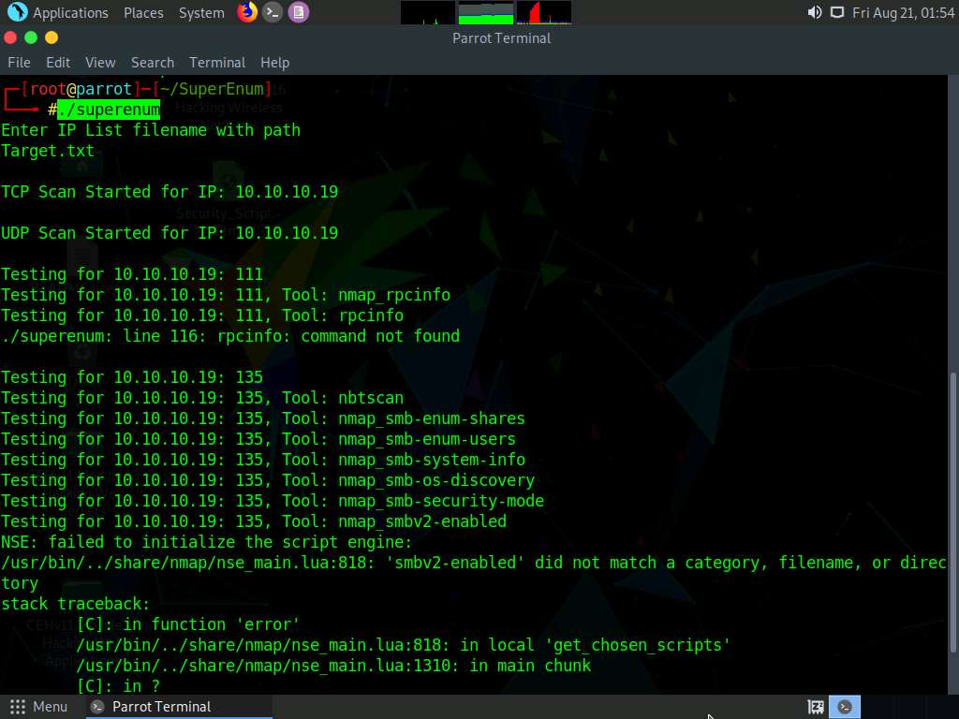

1. After the scan is finished, scroll down to review the results. Note that port 2049 is open and the NFS service is running on it.

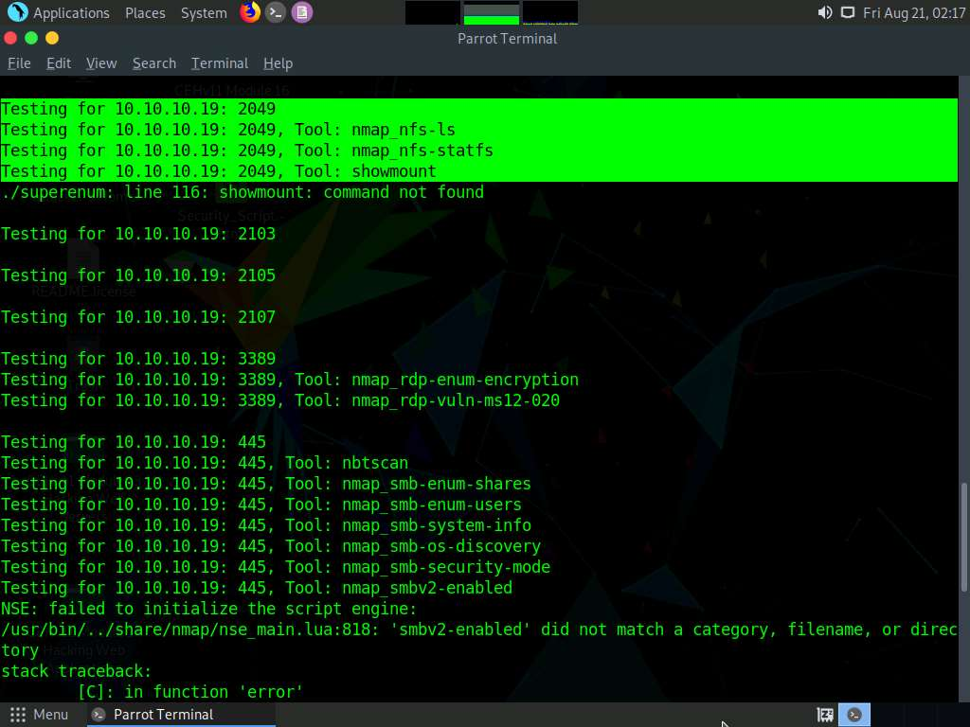

1. You can also observe the other open ports and the services running on them.
2. In the terminal window, type **cd ..** and press **Enter** to return to the root directory.
3. Now, we will perform NFS enumeration using RPCScan. To do so, type **cd RPCScan** and press **Enter**

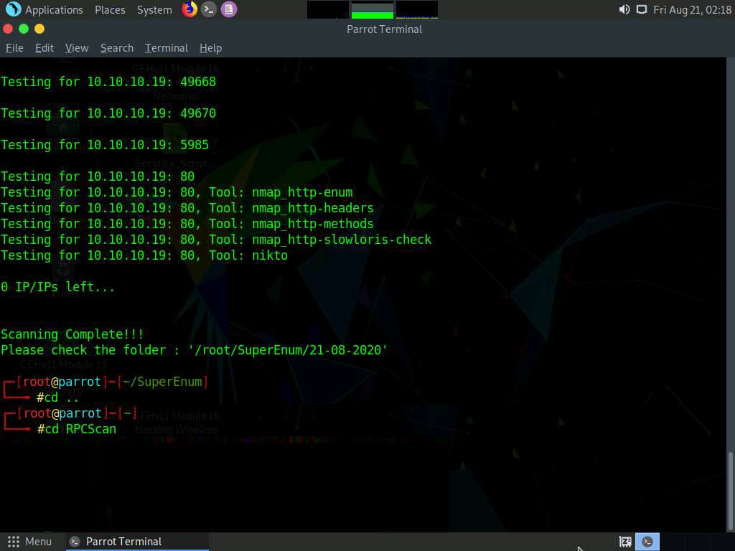

1. Type **python3 rpc-scan.py [Target IP address] --rpc** (in this case, the target IP address is **10.10.10.19**, the **Windows Server 2019** machine); press **Enter**.

**--rpc**: lists the RPC (portmapper); the target IP address may differ in your lab environment.

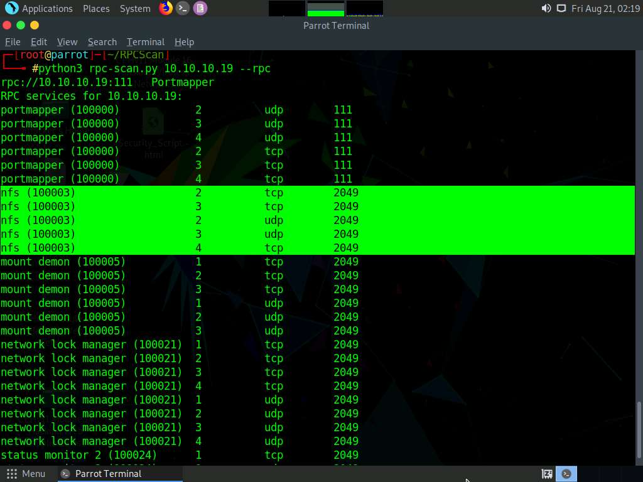

1. The result appears, displaying that port 2049 is open, and the NFS service is running on it.

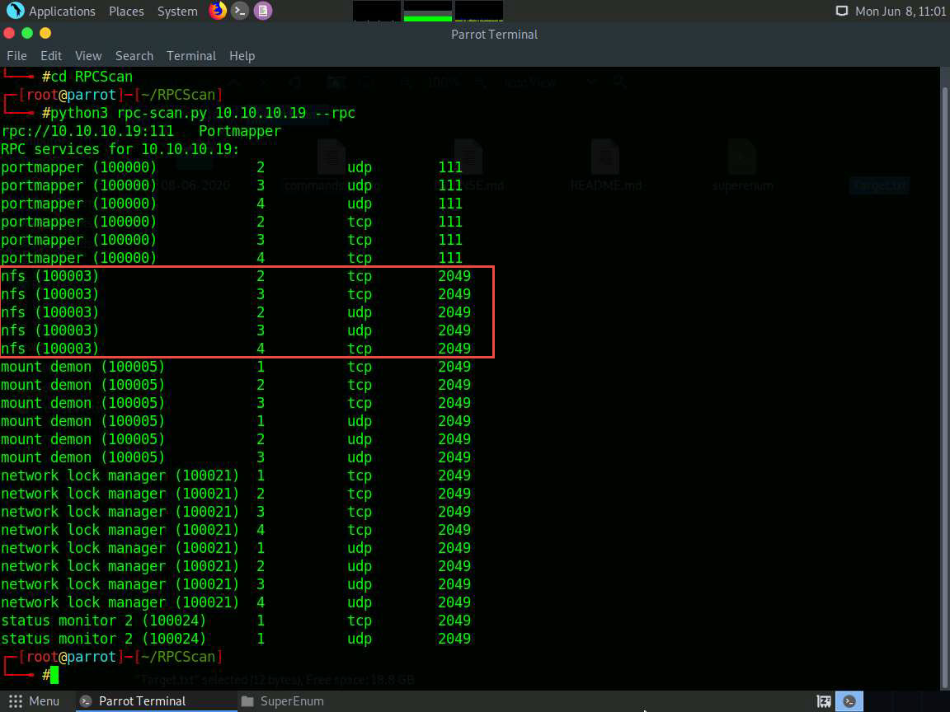

1. This concludes the demonstration of performing NFS enumeration using SuperEnum and RPCScan.
2. Close all open windows and document all the acquired information.